UDC
Full name (Name of organization)

Title of the paper

Text of the paper [references are numbered in Arabic numerals in order of reference].

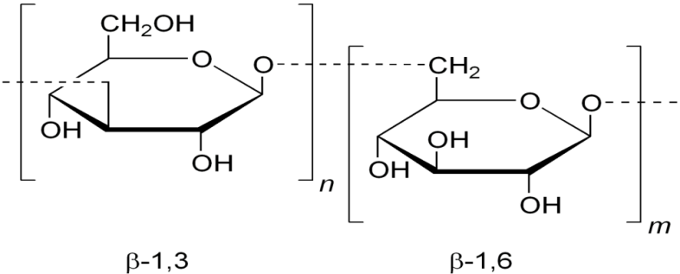

Figure 1 – The name of the figure

Table 1 – The name of the table

REFERENCES
1. Mousavi, S.M. Effect of ultrasonic irradiation on rheological properties of asphaltenic crude oils / S.M. Mousavi, A. Ramazani, I. Najafi // Petroleum Science. – 2012. – Vol. 9. – № 1. – P. 82-88.
2 Батыжев, Э.А. Выбор растворителей асфальтеновых комплексов при термодеструкции нефтяных остатков / Э.А. Батыжев // Технология нефти и газа. – 2005. – №4. – С. 29-32.

